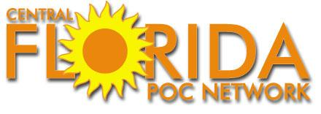 CLMA 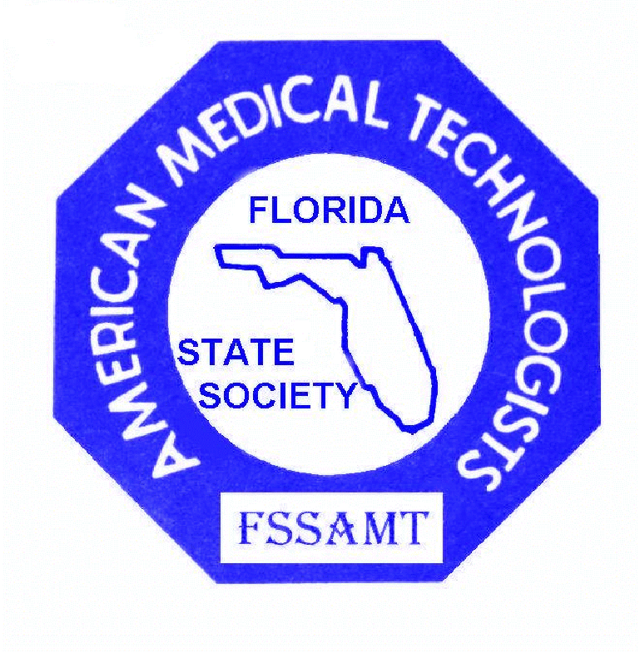

WINTER CONTINUING EDUCATION CONFERENCE
CENTRAL FLORIDA POINT OF CARE NETWORK
GULF COAST CHAPTER - CLMA
and the
FLORIDA STATE SOCIETY of AMERICAN MEDICAL TECHNOLOGISTS
Friday, January 30 and January 31, 2015

KEISER UNIVERSITY, 2400 Interstate Drive, Lakeland, Florida, 33805
For more information, call (904) 282-9040 or e-mail: kayfergason@gmail.com

EARLY BIRD DISCOUNT - REGISTER BY JANUARY 15, 2015 AND GET A 10% DISCOUNT!

PROGRAM

FRIDAY, January 30, 2015
1:00 pm – 3:30 pm REGISTRATION

1:30 pm – 2:20 pm 1. HOW OUR LABORATORY AND EMERGENCY DEPARTMENT
1 contact hour COMBINED EFFORTS TO ACHIEVE WORLD CLASS RESULTS
Admin./Supv. Acceptable “turn around times” are always a focus in any laboratory. Quality
patient care depends on it and can be achieved. Suggestions to improve your
numbers, while delivering accurate test results will be presented.
THERESA OHRMUND, MBA, MT (ASCP). CIC. ASQ, SSGB
Director of Laboratory Services, Lakeland Regional Medical Center, Lakeland
President, Gulf Coast Chapter, CLMA

1:30 pm – 2:20 pm 2. FDA REQUIREMENTS FOR USE OF GLUCOSE MONITORING
1 contact hour SYSTEMS IN INTENSIVE CARE UNITS
Chemistry Clinical use of Point of Care glucose testing in the hospital; description of the
analytical challenges of whole blood glucose testing; and regulatory changes
in point of care glucose testing.
EVANGELOS NTRIVALAS, M.D., PhD, HCLD/CC (AAB), D(ABMLI)
Director of Medical and Scientific Affairs, Nova Biomedical
Sponsored by NOVA BIOMEDICAL

1:30 pm – 4:40 pm 3. ANATOMY AND PHYSIOLOGY REFRESHER
3 contact hours This session is designed to review Anatomic Descriptors and Fundamental Body Structures.
General Included is a review of each body system with diagnostic examinations and diseases and disorders
integrated throughout the presentation. The objective of the presentation is to overview each of the
following areas: Body Structures, the Nervous System, the Senses, the Integumentary System, the Skeletal System, the Muscular System, the Respiratory System, the Circulatory System, the Immune System, the Digestive System, the Endocrine System, the Urinary System, and the Reproductive System. As time permits, a brief review of Medical Terminology will be presented.
DEBORAH JANECZKO, M.Ed, RMA (AMT), Educational / Healthcare Consultant;
Program Director/Faculty, Medical Assistant Program, Midway College Online
LINDA ROBERTS, RMA, AHI (AMT), Retired Allied Health Instructor

FRIDAY, January 30, 2015 continued

2:30 pm – 3:20 pm 4. TECHNICAL TOXICOLOGY FOCUS FOR THOSE CONSIDERING
1 contact hour IN-HOUSE TESTING
Toxicology/Chemistry What to know and not know about confirmation testing, etc.
DAVE MICHAELSEN, BS, Chemistry and Criminal Justice; MS, Forensic Chemistry
Director of Separation Science and Toxicology, Pathology Associates Medical Laboratories,
Spokane, Wa., Laboratory Director for 4 high complexity DOA labs, Technical Supervisor
for 4 additional high complexity labs. Sponsored by MEDTEST

2:30 pm – 3:20 pm 5. AUTOIMMUNE DISEASES
1 contact hour New approaches to laboratory diagnostic investigation.
Serology Dr. ERIC S. HOY, Ph.D., SI(ASCP), Clinical Associate Professor (retired)
Department of Medical Laboratory Sciences
The University of Texas Southwestern Medical Center, Dallas
Sponsored by: GLOBAL FOCUS MARKETING and DISTRIBUTION, Ltd.

3:20 pm – 3:50 pm REFRESHMENT BREAK
Sponsored by ROCHE POINT OF CARE DIAGNOSTICS
VISIT WITH YOUR EXHIBITORS / DOOR PRIZE DRAWINGS

3:50 pm – 4:40 pm ANATOMY AND PHYSIOLOGY REFRESHER CONTINUED

3:50 pm – 4:40 pm 6. PATIENT SAFETY: A QUALITY SYSTEM APPROACH TO POCT QC/QA
1 contact hour The quality management system approach applies a core set of “quality system
Admin./Supv. essentials” to the provision of diagnostic testing. There are multiple QA issues with
Point of Care Testing (POCT) due to the nature of the testing and the rapid availability
of results. In POCT, even though there has been an overall reduction in errors, the
majority occur in contrast to lab based testing, during the analytical phase. Appropriate
QC procedures are an essential part of the Quality Management System and must be able
to detect and prevent mistakes to assure patient safety.
ELLIS JACOBS, PhD, DABCC, FACB, Director of Scientific Affairs. Adjunct Associate
Professor of Pathology, The Mount Sinai School of Medicine, New York
Sponsored by: ALERE

3:50 pm – 4:40 pm 7. COLON CANCER DIAGNOSTIC TOOL: FECAL OCCULT BLOOD
1 contact hour TESTING IN THE MODERN ERA
Microbiology Discussion of the guaiac based test introduced in 1971 and its’ shortcomings
versus Fecal Immunochemical Testing (FIT) and how it relates to acute and
non-acute facilities. Why is FIT the preferred test?
ROB KISFALUSI, Southeast Regional Manager, Hemosure
Sponsored by HEMOSURE

SATURDAY, January 31, 2015

8:30 am – 3:00 pm REGISTRATION

9:00 am – 9:50 am 8. FLORIDA LABORATORY PERSONNEL LAW AND RULES
1 contact hour As a licensed Clinical Laboratory Employee in the state, it is your responsibility
Law/Rules to be familiar with the law and rules that govern the laboratory profession.
Ignorance of the law is never a valid excuse if you are cited for non-compliance.
CARLEEN VAN SICLEN, MS, MLS (ASCP)^{CM}, TS (ABB)
Governor Appointee, Vice Chair, Florida Board of Clinical Laboratory Personnel
Education Coordinator, Department of Laboratory Medicine and Pathology
Mayo Clinic, Jacksonville
*Mandatory course for re-licensure of Laboratory personnel.

9:00 am – 9:50 am 9. EBOLA VIRUS DISEASE: FROM EPIDEMIOLOGY AND EMERGENCY
1 contact hour MANAGEMENT TO ETHICS
Microbiology A review of Ebola Virus disease including the current outbreak in West Africa, local
and international emergency response, epidemiology and ethical aspects of the disease.
PAUL YATES, BS, DLM (ASCP), CIC (CBIC)
Infection Control Director, Health First, Melbourne

9:00 am – 11:55am 10. MEDICAL ASSISTANT NATIONAL CERTIFYING EXAM READINESS
3 contact hours REVIEW Part 1. ADMINISTRATIVE
General Are you ready to take your credentialing exam? What do you need to know? How can you
*AMT credit only get ready? Also a good review for practicing Medical Assistants who may need continuing
education or continued competency points to renew their national certification.
ALICE MACOMBER, RN, RMA, RPT, AHI (AMT); LMXO
Retired Allied Health Instructor, Consultant, Port St. Lucie

10:00 am – 10:50 am 11. HIV / AIDS
1 contact hour A review of the past and outlook for the future of the HIV Pandemic.
HIV / AIDS KAREN KELLY, MLS (ASCP), Microbiology Supervisor,
Watson Clinic LLP Micro Lab, Lakeland
*Mandatory course for re-licensure of Laboratory personnel.

10:00 am – 10:50 am 12. CHROMOSOMES, OUR (Genetic) BOOK OF LIFE
1 contact hour A change in the number or structure of chromosomes can cause problems with growth,
Molecular Pathology development, and function of the body’s systems. We will take a look at what chromosomes
are , how important they are to cell growth, and a molecular laboratory’s approach with
assisting in diagnosis.
OZZIE SKINNER, MT (AMT), CLT (HHS), MAOM
Supervisor, Molecular Diagnostics Laboratory, VA Medical Center, Tampa
*Note: One hour of Molecular CE is required for all Laboratory personnel who have had Molecular Pathology added to their
state license and wish to retain this classification upon renewal.

10:50 am – 11:10 am REFRESHMENT BREAK VISIT WITH YOUR EXHIBITORS

11:10 am – 12:00 pm MA NATIONAL CERTIFYING EXAM REVIEW Part 1. Administrative continued.

REMEMBER, if you attend a 1 hour course, a 2 hour course, or a 3 hour course, you MUST stay in that course for
the entire session to receive continuing education credit for it. No partial credit can be awarded for any course`

SATURDAY, JANUARY 31, 2015 continued

11:10 am – 12:00 pm 13. PHYSICIANS ARE FRIENDS, NOT FOOD! BUILDING PHYSICIAN
1 contact hour PARTNERSHIPS IN BLOOD BANK.
Immunohematology Learn to build collaborative relationships with physicians. This workshop will demonstrate
how blood bank technologists can take a proactive approach and educate physicians on
best practices in transfusion decisions.
KRISTEN N. CORREIA, MPH, MT (ASCP)
Administrative Laboratory Director, Northside Hospital, St. Petersburg

11:10 am – 12:50 pm 14. IDENTIFICATION AND PREVENTION OF MEDICAL ERRORS
2 contact hours Understand why errors occur and the efforts that have been made to prevent them
Medical Errors in Healthcare. Participate in group exercises utilizing standard tools for identification,
analysis, remediation, and prevention of errors.
VALERIE FULDAUER, MSHL, MT (ASCP) QLC
Ethics and Compliance Officer JFK Medical Center, Atlantis
*Mandatory for laboratory licensure and re-licensure in Florida

12:00 pm – 12:50 pm 15. LABORATORY DIAGNOSIS OF HEPARIN-INDUCED THROMBOCYTOPENIA
1 contact hour Heparin-induced thrombocytopenia (HIT) is one of the most frequent drug-induced
Hematology immune mediated types of thrombocytopenia that affects 1 – 5% of patients receiving
heparin. It is a serious, life-threatening disorder that relies on laboratory testing to diagnose.
CINDY JOHNS, MSA, MASCP, MLS(ASCP)^{CM}SH^{CM}
Sr. IT Technical Specialist, Test Master, LabCorp

12:00 pm - 12:50 pm 16. BIPOLAR DISORDER
1 contact hour Take the test to see if you may be a candidate for this disorder. Symptoms, signs, and
General treatment will be discussed.
SOLOMON GOLDENBERG, MSc, FRCGP, RMA (AMT), ,
*AMTIE credit only Neurology Associates Group, Miami, (Formerly a Physician from London, England).

12:50 pm – 1:40 pm LUNCH (included)
VISIT WITH YOUR EXHIBITORS - DOOR PRIZE DRAWINGS

1:40 pm – 2:30 pm 17. BLOOD GASES
1 contact hour Discussion will focus on what is measured and why. The diagnosis of specific respiratory
Blood Gases diseases rely heavily on these test results and will be addressed along with instrumentation
maintenance, quality control and quality assurance.
SILVIA ROMERO, BS, MT (AMT)(ASCP), MS Health Services Administration,
MSN - Family Practice, ARNP, Take Care Health Clinic @ Walgreens

1:40 pm – 3:30 pm 18. HOW BOOMERS WILL AFFECT HEALTHCARE IN THE 21st CENTURY
2 contact hours Everyday for the next 19 years, 10,000 Baby Boomers will retire. About 50% of these
Admin. / Supv. anticipate retiring before they turn 70. This presentation will review the enormous impact
this generation will have on the ability of the US to provide healthcare for this population
by taking a deep look into societal trends, how healthcare can be provided to this huge
population, what type of care will be needed, and most noticeable, how much will all of
this and who pays?
LEROY MELL, PhD., MBA, HCLD (ABB)
Senior Director, Laboratory, Piedmont Healthcare, Atlanta

SATURDAY, JANUARY 31, 2015 continued

1:40 pm – 4:45 pm 19. MEDICAL ASSISTANT NATIONAL CERTIFYING EXAM READINESS
3 contact hours REVIEW Part 2: CLINICAL
General Are you ready to take your credentialing exam? What do you need to know? How can
*AMT credit only you get ready? Also a good review for practicing Medical Assistants who may need
continuing education or continued competency points to renew their national certification.
DEBORAH JANECZKO, M.Ed, RMA (AMT), Educational / Healthcare Consultant;
Program Director/Faculty, Medical Assistant Program, Midway College Online

2:40 pm – 3:30 pm 20. BEING A MEDICAL ASSISTANT IN TODAY’S WORLD
1 contact hour We are going to look at how the role of the Medical Assistant is evolving with the upcoming
General changes in healthcare. We will take a hands-on approach in the use of ICD-10-CM, as well
*AMT credit only as discuss HITECH and meaningful use.
JAN ROBERTS, RMA, CPC, CCS-P
Instructor, Allied Health; Community Technical Adult Education, Ocala

3:30 pm – 3:55 pm REFRESHMENT BREAK
VISIT WITH YOUR EXHIBITORS - DOOR PRIZE DRAWINGS

3:55 pm – 4:45 pm MA NATIONAL CERTIFYING EXAM REVIEW Part 2. Clinical continued

3:55 pm – 4:45 pm 21. TROPONIN: AN UPDATE TO ASSAY REFERENCE VALUES AND
1 contact hour INTERPRETATION
Chemistry Have you gotten rid of the “grey zone” in your lab? A brief review of the latest
recommendations for the use of cardiac troponin to diagnose cardiovascular
diseases will be presented. Also, the discussion of the results of a detailed study
which included the 99th percentile revision and cardiac troponin reference values
and report interpretation adjustments.
CARLOS A. LOPEZ-RIVERA, PhD, MT (ASCP)
Clinical Laboratory Supervisor, Chemistry Department
Lakeland Regional Medical Center, Lakeland

3:55 pm – 4:45 pm 22. TRAVEL MEDICINE AND THE MICRORGANISMS THAT WANT
1 contact hour TO TRAVEL WITH YOU
Microbiology NAOMI MELVIN, PhD/EdD, MPH, CLC/MT (AMT), CLS/ MLS(ASCP)
President, World of Wellness Online2U, Sdn, Bhd, Kuala Lumpur, Malaysia
Director, SBC Lab Consultants, Chipley

.

C E CREDITS PROVIDED BY: STATE OF FLORIDA (through C E BROKER) # 50 – 2288
and AMERICAN MEDICAL TECHNOLOGISTS

*AMT credit only - applies to courses that are not laboratory related and not counted towards laboratory license renewal for Florida and
Tennessee State licensed Laboratory personnel. Although these courses are designed for credit and presented for other allied personnel
(Medical Assistants, Dental Assistants, Phlebotomists, Allied Health Instructors, laboratory personnel not licensed in Florida, etc.), who
need continuing education credit to renew their national certifications, anyone is welcome to attend and will be awarded AMT credit.

CLMA

PRE-REGISTRATION FORM
EARLY BIRD DISCOUNT - REGISTER BY JANUARY 15, 2015 AND GET A 10% DISCOUNT!

FSSAMT CONTINUING EDUCATION CONFERENCE

KEISER UNIVERSITY, LAKELAND
For more information, call (904) 282-9040 or e-mail: kayfergason@gmail.com

Name_____________________________________ PRE-REGISTRATION FEES
Prior to January 22, 2015
Address___________________________________ After January 22, 2015, add $10 late fee

City________________ State_______ Zip ________ MEMBERS NON-MEMBERS STUDENTS

E-mail address:______________________________ 2 days: $65 $75 $35
Friday only: $30 $35 $20
Phone: home ___________ work __________ Saturday only: $45 $50 $25

Employer:________________________________ Full day registration includes lunch.

Student: Yes _____ No _____ School____________________________________ Program________________________

AMT Member: Yes___ No___ AMT Membership # ____________ POCT Member: Yes___ No___ CLMA Member: Yes___ No___

Member of another Professional Organization? (please indicate name)__________________________________________

Your job, license or certification classification:
Dir. ____ Supv. ____ CLC ___ AHI ____ MLS ____ MT ____ MLT ____ CMLA ____ RMA ____ RDA ____ RPT ____

Make checks payable to:FSSAMT (Sorry, we are not set up to accept credit cards. Cash, check or Money orders only.)
Mail to: FSSAMT, c/o Kay Fergason, 3712 Arava Drive, Green Cove Springs, Florida 32043

Please circle the number of each session you plan to attend: DO NOT circle them all – 3 classes will be presented at the same time.

1 2 3 4 5 6 7__ 8_ 9_ 10_ 11_ 12_ _13__14 15 16 17 18 19 20 21 22 .

REMEMBER, if you attend a 1 hour course, a 2 hour course, or a 3 hour course, you MUST stay in that course for the entire session to receive continuing education credit for it. No partial credit can be awarded for any course.

For our out of town guests, our host hotel is: The Baymont Inn, 4375 Lakeland Park Drive,
Lakeland, Fl. 33809 Phone for reservations: (863) 858 - 9070
Ask for the AMT special rate of $75, plus tax. Restaurants within walking distance.

