Location:
Owens Auditorium, located in the Cancer Center at Johns Hopkins Hospital

Registration Fee:
$25 (includes Registration, Breakfast, Lunch and Light Fare for Breaks)

Parking:
All day parking for $11 or take Maryland Metro subway East bound to Johns Hopkins stop

Agenda:
8:00am Registration and Breakfast
8:30am Why do Method Validation?
9:00am Method Validation in the Real World
9:45am Break
10:15am Statistical Sense and Sensitivity
11:00am Method Decisions and Acceptance Charts
12:00pm Lunch
1:00pm Other Experiments: Interference, Recovery, Detection Limit, Reference Range
1:50pm Evaluating Qualitative Tests: No Numbers, No Problem! Right?
2:40pm Break
3:10pm Validation of Molecular Tests
4:00pm Adjourn; Capital Section and CPCOT/BPCOT Executive Committee Meetings
Sponsors:
The Workshop is generously sponsored by: Alere, Beckman Coulter, HemoCue, Maine Molecular Quality
Controls, Inc, Nova Biomedical, Radiometer, and SeraCare Life Sciences.

RSVP:
Please RSVP to Danni Meany (dmeany1@jhmi.edu) by March 14th, 2011. In addition to email RSVP, Pre
registration by mail is strongly recommended (see attached Pre-registration form). On-site Registration will be available, but participation will be guaranteed only for Pre-registered participants.
Directions:
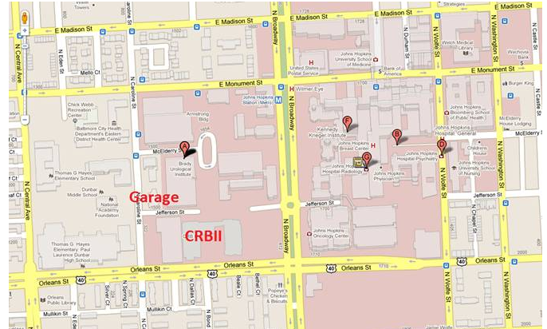
Owens Auditorium is located in the David H. Koch Cancer Research Building (also called CRBII Bldg), Johns Hopkins Medical Campus, Baltimore, MD. CRBII is 1550 Orleans Street, Baltimore, MD 21287. The parking garage and CRBII are labeled in the following map.

Speaker Biographies:

R. Neill Carey, Ph.D. Clinical Chemist, Emeritus
Peninsula Regional Medical Center in Salisbury, MD

Dr. Carey’s special interests are QC, the application of statistical methods to method evaluations, and sailing. He is active in the Capital Section AACC, and is currently Student Awards Chair. Neill has participated in CLSI for many years, and has been a member of the Area Committee on Method Evaluation, the CLSI EP5 (Precision), CLSI EP9 (Comparison of Methods Using Patient Samples), and CLSI EP15 (User Verification of Performance for Precision and Trueness) subcommittees at different times. He is currently chair of the CLSI EP15 subcommittee. He participated in the longest-running AACC workshop "Concepts and Practices in the Evaluation of Laboratory Methods" from 1977 through 2010.

Patricia Garrett, Ph.D.
Senior Director for Science and Technology at SeraCare

Dr. Garrett is a Clinical Chemist who has worked for SeraCare Life Sciences and its predecessor company Boston Biomedica (BBI) for 23 years. She has made significant contributions to BBI’s Product Development, Quality Assurance, Regulatory Affairs, Intellectual Property, and Clinical Trials efforts. Dr. Garrett’s interests are infectious disease diagnostics, with emphasis on method evaluation, QC and PT. She has served on the AACC Nominating Committee, Board of Directors for ABCC and on the Executive Board of the Northeast Section of AACC. She is a member of AMP (Association for Molecular Pathology), PASCV (Pan American Society for Clinical Virology), and AAAS (American Association for the Advancement of Science), and volunteers as a writer and reviewer with CLSI.

Clark A. Rundell, Ph.D.
Vice President for Research at Maine Molecular Quality Controls, Inc.(MMQCI) and, Assistant Laboratory Director for Cambridge Biomedical Research Clinical Laboratory

Sten Westgard, M.S.
Director of Client Services and Technology for Westgard QC and adjunct faculty for Mayo School of Health Sciences.

Sten Westgard has managed the Westgard website and course portal, has edited or authored hundreds
of reports, essays, and applications on quality control, method validation, Six Sigma Risk Management and other laboratory management topics. He has edited and contributed to numerous books on quality, including Basic QC Practices, Basic Method Validation, Six Sigma QC Design and Control, CLIA Final Rules, Assuring the Right Quality Right, and Nothing but the Truth about Quality.

PRE-REGISTRATION FORM

Please RSVP to:
Danni Meany (dmeany1@jhmi.edu) by March 7th, 2011.

Pre-registration by mail is strongly recommended. On-site registration will be available,
but participation will be guaranteed only for pre-registered participants.

Checks for registration ($25) should be made out to “AACC Capital Section” and mailed to:

Danni Meany, 1550 Orleans Street , Room 3M06, Baltimore, MD 21287

Participant Name:
Participant Title:
Participant Address:
City:
State:
Zip:
Phone:
Email:

Registration Fee:
$25.00

Questions?
Please contact Lorin Bachmann, lbachmann@mcvh-vcu.edu (804-828-6407)

