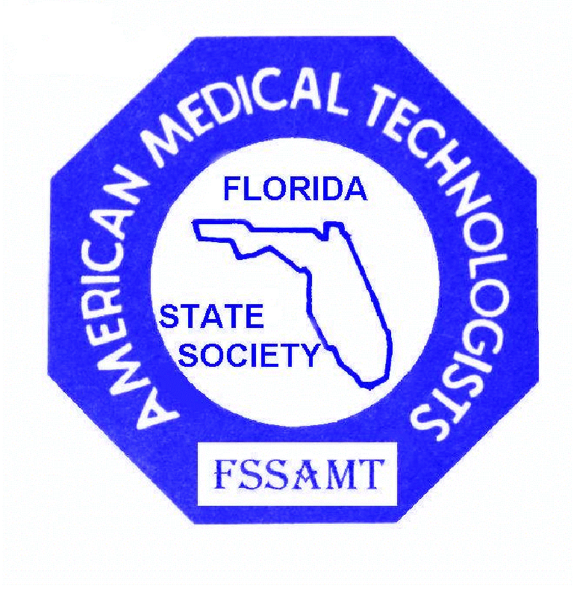

11TH ANNUAL CONTINUING EDUCATION CONFERENCE
of the
CENTRAL FLORIDA POINT OF CARE NETWORK
and the
FLORIDA STATE SOCIETY of AMERICAN MEDICAL TECHNOLOGISTS

Friday, November 18 and Saturday, November 19, 2011
HOWARD JOHNSON PLAZA HOTEL
230 WEST STATE ROAD 436, ALTAMONTE SPRINGS, FLORIDA 32714

PROGRAM

For more information, call (904) 282-9040 or email: edwina.szelag@aol.com or flakaylab@yahoo.com

Friday, November 18, 2011

7:30 am – 1:30 pm REGISTRATION

8:00 am – 8:50 am 1. DIAGNOSING AND MANAGING SEPSIS SYNDROME:
1 contact hour THE EMERGING ROLE OF BEDSIDE ANALYTE TESTING
Microbiology CHRISTIE BUDRIS, RN, BSN, Clinical Consultant
Critical Care Group, Alere North America
Sponsored by Alere North America, Inc.

9:00 am – 9:50 am 2. FLORIDA LABORATORY PERSONNEL LAW AND RULES
1 contact hour BRENDA VAN DER HEYDEN, BSMT (ASCP)
Law / Rules Governor Appointee and Chair of the Florida Board of Clinical
Laboratory Personnel
*Mandatory for laboratory re-licensure in Florida

9:50 am – 10:15 am COFFEE BREAK VISIT WITH YOUR EXHIBITORS

10:15 am – 12:00 pm 3. FEATURE SPEAKER
2 contact hours ACHIEVING QUALITY AT THE POINT OF CARE
Supv. – Admin. JAMES H. NICHOLS, Ph.D., DABCC, FACB
Professor of Pathology, Tufts University School of Medicine
Medical Director, Clinical Chemistry, Baystate Health, Springfield, Mass.
Sponsored by Blue Medical Supply, Inc.
Friday, November 18, 2011continued

12:00 pm – 1:00 pm LUNCH (included) VISIT WITH YOUR EXHIBITORS

1:00 pm - 2:20 pm 4. CLIA AND AHCA UPDATES
1.5 contact hours with AHCA focus on Alternate Site Testing Rule
Supv. / Admin. GWENDOLYN WILLIAMS, MS, MT (ASCP),
Laboratory Consultant, CLIA Regional Office,
CMS, Atlanta, Georgia
DAYLE D. MOONEY, Program Administrator, Laboratory Unit
KAREN RIVERA, MS, Laboratory Unit Manager
Florida Agency for Healthcare Administration. Tallahassee

2:20 pm – 2:40 pm REFRESHMENT BREAK VISIT WITH YOUR EXHIBITORS

2:40 pm – 3:30 pm 5. HOT TOPICS IN TRANSFUSION MEDICINE
1 contact hour Clinical significance and mitigation strategies of bacterial contamination in platelets;
Immunohematology overview of platelet additive solutions risk and benefits; pros and cons of remote
allocation from a centralized transfusion service and pertinent current isses
RICHARD GAMMON, MD, Medical Director
Medical Services Department, Florida Blood Centers, Orlando

3:40 pm – 4:30 pm 6. POINT OF CARE ROUND TABLE DISCUSSION
1 contact hour Sharing of information and ideas with audience participation.
General EDWINA F. SZELAG, MHM, BSMT(ASCP),
Associate Healthcare Consultant, Huron Consulting Group, Chicago
MARY JO GRODSKY, BS, MLS(ASCP)
Lab Coordinator, Point of Care Testing
Orlando Regional Medical Center, Orlando Health

SATURDAY, NOVEMBER 19, 2011
7:30 am – 1:30 pm REGISTRATION

8:00 am – 9:20 am 7. MONITORING ANTICOAGULANT THERAPY:
1.5 contact hours BEYOND THE APTT
Hematology CINDY JOHNS, MSA, MASCP, MLS(ASCP)^{CM}SH^{CM}
Sr. IT Technical Specialist, LabCorp

8:00 am – 12:00noon 8. MEDICAL ASSISTANT REVIEW (Administrative and Clinical)
and Review for upcoming national certification examinations, earn continuing
1:00 pm – 4:10 pm education credits for your re-certification or just refresh your skills and
knowledge base.
7 contact hours ALICE MACOMBER, RN, RMA, RPT, AHI (AMT), CPI, BXO
Medical Assisting Medical Assisting University Department Chair, Florida Keiser Universities
DEBORAH JANECZKO, RMA (AMT), MA-CTE,
Educational / Healthcare Consultant, Program Director / Faculty,
*AMTIE credit only Medical Assisting Program, Midway College

9:20 am – 9:40 am COFFEE BREAK VISIT WITH YOUR EXHIBITORS
SATURDAY, NOVEMBER 19, 2011 Continued

9:40 am – 10:30 am 9. HIV / AIDS UPDATE
1 contact hour KAREN KELLY, MT (ASCP), Microbiology Supervisor,
HIV /AIDS Watson Clinic, Lakeland
*Mandatory for laboratory licensure and re-licensure in Florida

10:40 am – 12:00 pm 10. pH INFLUENCE ON TESTS IN CLINICAL CHEMISTRY
1.5 contact hours ERIC S. HOY, PhD, SI(ASCP), Clinical Associate Professor
Chemistry Department of Medical Laboratory Sciences
The University of Texas Southwestern Medical Center, Dallas
Sponsored by Global Focus Marketing and Distribution, Ltd.

12:00pm – 1:00pm LUNCH (included) DOOR PRIZE DRAWINGS
VISIT WITH YOUR EXHIBITORS

1:00 pm – 2:50 pm 11. MEDICAL ERRORS
2.0 contact hours NAOMI MELVIN, PhD/EdD, MPH, CLC/MT (AMT), CLS/ MLS(ASCP)
Medical Errors President, Patient Care Practitioners, LLC, Chipley,
President, World of Wellness Online2U, Sdn, Bhd, Kuala Lumpur, Malaysia
*Mandatory for laboratory licensure and re-licensure in Florida



CONTINUING EDUCATION CREDITS PROVIDED BY:

STATE OF FLORIDA through CE BROKER Provider # 50 – 2288

AMERICAN MEDICAL TECHNOLOGISTS INSTITUTE FOR EDUCATION # 823307

The “ * AMTIE credit only” notice on the Medical Assistant Review course signifies that this course is not lab related - therefore
may not be used for renewal credits of your Florida Laboratory license. RMA’s will receive credits towards their AMT
Continued Competency Points.
All other courses are approved for State (CE Broker) and AMTIE credits.

Directions to the Howard Johnson Plaza Hotel:
Your host hotel (home of the legendary “Why Not Lounge”) is located at 320 West State Road 436, Altamonte Springs, 32714 (Orlando). It is within blocks of multiple restaurants and a huge shopping mall and only 8 miles north of downtown Orlando. Take I-4 to exit 92 (Semoran Blvd / Hwy 436), go west to the first traffic light. Turn left on Wynmore Road. and you will see the hotel entrance on the right (behind the Walgreen’s).

****For those who will be staying overnight, please ask for the AMT/POC special rate of $59 plus tax, rooms surrounding the pool or $69 plus tax for a room in the Executive building. Call (407) 862 – 4455 to make your reservation early, as rooms are limited.

