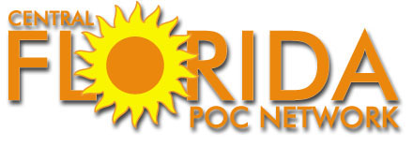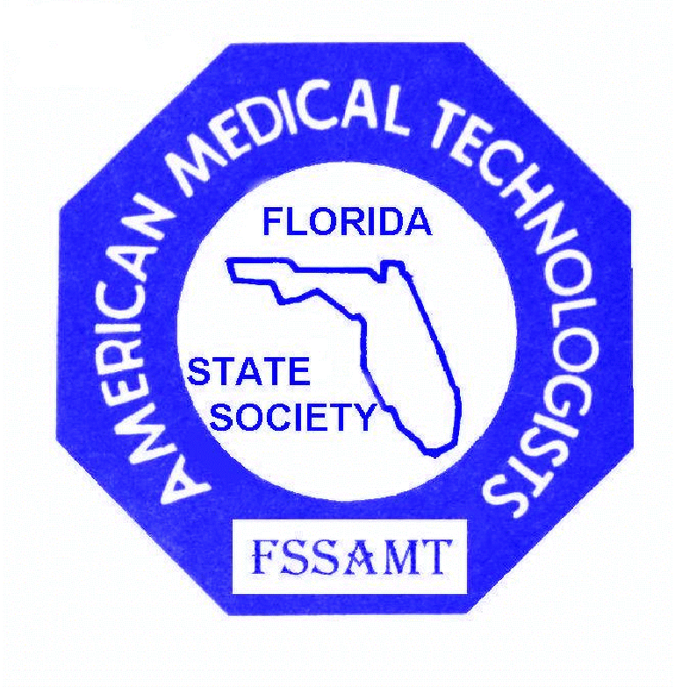

11TH ANNUAL CONTINUING EDUCATION CONFERENCE
of the
CENTRAL FLORIDA POINT OF CARE NETWORK
and the
FLORIDA STATE SOCIETY of AMERICAN MEDICAL TECHNOLOGISTS

Friday, November 18 and Saturday, November 19, 2011
HOWARD JOHNSON PLAZA HOTEL
230 WEST STATE ROAD 436, ALTAMONTE SPRINGS, (ORLANDO), FLORIDA 32714

PRE - REGISTRATION FORM

For more information, call (904) 282-9040 or email: edwina.szelag@aol.com or flakaylab@yahoo.com

Name________________________________________ PRE-REGISTRATION FEES
Prior to November 11, 2011
Address______________________________________ After November 11th or at the door, add $10

City__________________ State_______ Zip ________ MEMBERS NONMEMBERS STUDENTS
Both days $80 $90 $30 each day
E-mail address:________________________________ (includes lunch)

Phone: home _____________ work ___________ One day: $45 $50 $30 each day
(includes lunch)
Employer ____________________________________ Please check: Friday______ Saturday_____

CFPOC Member: Yes_____ No_____ AMT Member: Yes _____ No _____ AMT Membership # _______________

Member of another Professional Organization? (please indicate name)__________________________________________

Your job, license or certification classification: Check all that apply

Dir ___ Supv ____ AHI ____ MT ____ MLT ____ RMA ____ RPT ____ Educator_____ POC Coord. _____

Make checks payable to : FSSAMT
Mail to: FSSAMT, c/o Kay Fergason, 3712 Arava Drive, Green Cove Springs, Florida 32043

Please circle the sessions you plan to attend:

1 2 3 4 5 6 7____8____9____10____11____

