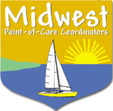
Midwest POCC meeting
Hosted by Children’s Hospital of WI at the Oakwood Center
May 24th, 2007

REGISTRATION FORM
RSVP by May 15th

Name:

Title/Position:

Facility/Business:

Address:

City/State:

Telephone:

Fax:

E-mail address:

Admission price: Free for those who submit one POC coagulation question for round table discussion. (Please submit question with registration)

Question:

Save as a word document and send to Barb Roettgen via e-mail or fax:
BRoettgen@chw.org
FAX: 414-266-3150

Need more information? Call Barb Roettgen 414-266-6624

