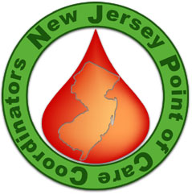

R E G I S T R A T I O N

NJ-POCCs Meeting
Thursday, December 8, 2005
9:00 AM to 2:30 PM

Sponsored by ITC - Hosted by UMDNJ

Please complete this form and fax it to Mohamed at 201-447-8657

_____ I will be attending the Meeting (RSVP by December 2, 2005)

For more information contact: Mohamed at 201-447-8552.

Name: _______________________________________________________________________

Title: _________________________________________________________________________

Institution: ____________________________________________________________________

Address: _____________________________________________________________________

City: _________________________________________ State & Zip: _____________________

Phone: _______________________________________________________________________

Fax: _________________________________________________________________________

E-mail: _______________________________________________________________________

Feel free to copy this registration form for any additional people who are interested in attending this Meeting from your organization.

