North Texas Point of Care Network 5th Annual Education Conference
When: May 6, 2011 0800-1600
Where: Medical City Dallas Hospital
7777 Forest Lane Bldg E, City Hall Auditorium
Dallas Texas 75230

Speaker Sponsors


Attendee fee: $25.00 check made out to Medical City Hospital Community Fund or cash at sign in
Return registration via e-mail (Vickie.vandulman@hcahealthcare.com) or via fax (469) 484-2231

Attendee Name:
Attendee e-mail:
Attendee Facility:

Attendee Name:
Attendee e-mail:
Attendee Facility:

Agenda
0800-0850 – Meet and Greet, Vendor Exhibits
0900-1000 – Jackie Coleman, Ph.D.
Director of Scientific Affairs
Accumetrics, Inc. sponsored
AHA llB guideline on Platelet Function testing

1015-1130 – Chris Parker, CLS
Senior Technologist, Core Laboratory University of North Carolina
Radiometer America sponsored
Error-free preanalytics: Fact or friction?

1145-1330 – Lunch Provided by Medical City Dallas Hospital, Vendor Exhibits

1345-1445 – Alere sponsored: To Be Announced

1500-1600 – Rosemary C. De Leon, MT (ASCP), MHA
Vice President, Valley Baptist Health System
Siemens sponsored
A Focus on Cardiac Care

North Texas Point of Care Network 5th Annual Education Conference
When: May 6, 2011 0800-1600
Where: Medical City Dallas Hospital
7777 Forest Lane Bldg E, City Hall Auditorium
Dallas Texas 75230

Building CareTower E, Emergency Department Parking off Merit Drive
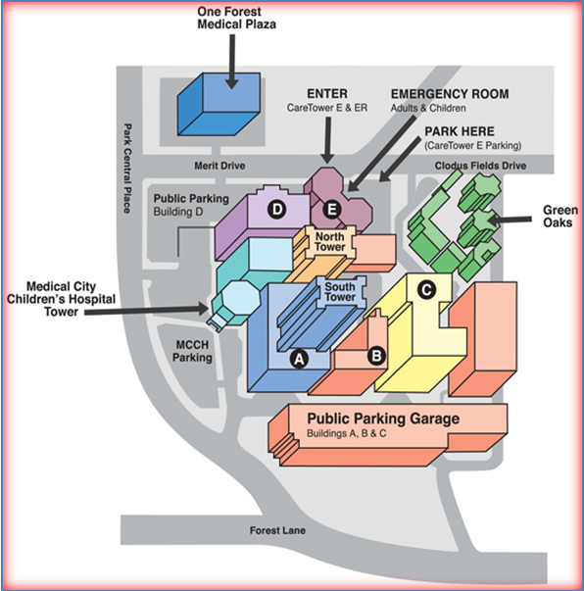

Hope you can make it…..

Be sure and take time to visit with each vendor exhibit!

Thanks to our Corporate Vendor Partners!

