North Country POC Network
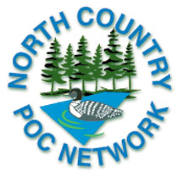
VENDOR REGISTRATION FORM

Make Payment to North Country POC Network
Submit with completed registration to:

Hennepin Country Medical Center
Minneapolis, MN 55415
Attn. Karen Kaestner P4 Lab

MEETING DATE & TIME: Friday, November 7, 2008 Set Up: 7:30 am

LOCATION OF MEETING: GUSTILO Medical Education Center
700 10 th Avenue South
Minneapolis, MN 55415

SPONSORSHIP FEE: $200 (Due October 15, 2008)

NAME OF SPONSORING COMPANY:

CONTACT PERSON:

PHONE NUMBER:

EMAIL ADDRESS:

BRIEF LISTING OF PRODUCTS YOU PLAN TO DISPLAY:

EQUIPMENT NEEDED:

We rely on sponsorship fees to help cover costs incurred for our meetings. These costs may include, but are not limited to: speakers, meeting room fees, audio/visual equipment, printed materials, food and beverages.

We appreciate your support as a sponsor. However, due to limited space, we ask that you please limit the number of representatives from you company to two (2).

Receipts will be distributed upon receipt of payment.
The meeting agenda can be viewed at the website: http://www.pointofcare.net/North_Country/index.htm (preliminary)

Inquires to Karen.kaestner@hcmed.org or Kendra.schmidt@hcmed.org

