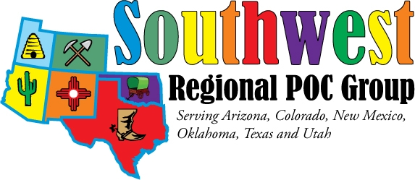
2014 Educational Seminar Registration Form

PLEASE PRINT Legibly

NAME

Company E-Mail

Mailing Address State ZIP

Daytime phone number __________________
_____ Yes, I am interested in attending Thursday’s sessions Sept. 18th
_____ Yes, I am interested in attending Thursday’s evening mixer
_____ Yes, I will be attending Friday’s sessions Sept. 19th
_____ Yes, I am interested in a raffle for a free night’s stay at hotel (out of town participants only) – drawing
to be held September 1st
Fees:
_____ $40 Registration
_____ $35 Registration
_____ AACC Member (Please send copy of your current membership card)
_____ $0 Student Registration
(Please indicate School __________________________________________)
Limited number of students accepted, please register early!
____ $20 Thursday evening dinner ____ $25 Guest dinner
Payment Options:
_____ Check Enclosed or _____ Will be paid at Event
or _____ Credit Card
If paying by credit card:
Name as it appears on card: ________________________
Card Number:_________________________
Expiration date:_____________ (ex: 12/2014)
Card Code (3 digit card verification number found on back of card)__________
Billing address:
________________________________________________________________

City_______________________ State__________ Zip Code______________

Mail to: SWRPOCG, c/o Kathleen David, Laboratory, 2211 Lomas Blvd NE, Albuquerque, NM 87048
Email to: Kathleen.David@tricore.org
Checks payable to: SW Regional POCG

Please communicate any special needs or considerations, along with your nomination for POC Coordinator of the year to Sid Strey at phleeb@hotmail.com

