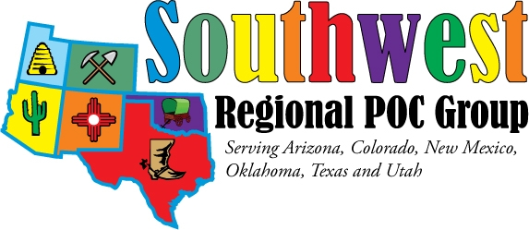
2024 Southwest Regional POC Meeting
Vendor Registration Form

NAME
Company E-Mail

Mailing Address State ZIP

Contact phone number __________________

Yes, our company is interested in hosting vendor booth. Donation amount ____________

One Thursday night dinner will be provided. Additional dinners requested: ______ $25 Guest dinner.
Please let us know the total count of attendees that will be at the Thursday night dinner._________
Payment Options:
Check Enclosed or Will be paid at Event or later date ________________
Credit Card

Name as it appears on card: ________________________
Card Number: _________________________
Expiration date: _____________ (ex: 12/2028)
Card Code (3-digit card verification number found on back of card) __________
Billing address:
________________________________________________________________

City_______________________ State__________ Zip Code______________

Mail to: SWRPOCG c/o Julie Aragon, 434 Capitol Dr SW, Los Lunas, NM 87031
Email to: Julie.Aragon@Tricore.org
Checks payable to: SW Regional POCG

To make room reservations at the Embassy Suites Biltmore
https://www.hilton.com/en/attend-my-event/southwestregionalpointofcare/
Or call 1-800-EMBASSY to make their reservations and refer to the 3 letter code -90D
Please make their reservations before October 11, 2024

Special needs for vendor space:
Electrical outlets needed ______________________________________________________
Other ______________________________________________________________________

