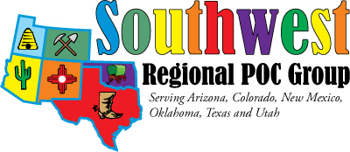

Greetings!

Announcing the Southwest Regional POC Group Annual Meeting! The meeting is November 7-8, and the venue is Embassy Suites Biltmore, 2630 East Camelback Road, Phoenix, AZ 85016.

The support of vendors has made the past SWRPOCG’s annual meetings a huge success and has been an opportunity many Point of Care and Laboratory professionals look forward to attending. Your contribution to the meeting will enable us to continue this tradition.

This year’s meeting is our 25th year of providing Point of Care Education. The theme is: Point of Care: Trail Blazers of HealthCare – Testing on the Go!

SWRPOCG is a not for profit 501(c)(3) charitable organization that relies on your contributions to provide affordable educational and networking opportunities to individuals involved in the oversight of point of care testing.

Your contribution this year will allow your company to participate in the vendor exhibits. This includes:
- Separate vendor area set aside from the meeting space.
- Dedicated exhibit time for participants along with prize drawings for participants who visit vendors. Limited spots are available with power connections if those are needed for your display items.
- Display table and draping.
- Dinner on Thursday night with the SWRPOCG members for one vendor per company, additional dinners available for a fee.

Your contributions are greatly appreciated and will be recognized on our webpage at www.pointofcare.net/Southwest/index.htm and in our meeting agenda.
Sponsorship levels:
Sustainers | $3,000 or more
Benefactors | $2,000 to $2,999
Sponsors | $1,000 to $1,999
Donors | $500 to $999
Contributors | $250 to $499
In addition, other sponsorship opportunities are available.

If Arizona is not in your geographic region, I would really appreciate your sending this email on to your company’s representative for Arizona.

If you can come forward as a sponsor, please fill out the attached form and scan to the email address listed on the form.

Please contact me should you have any questions. We’re looking forward to seeing you in November!

Sincerely,

Erin Levingston, President
SWRPOCG

