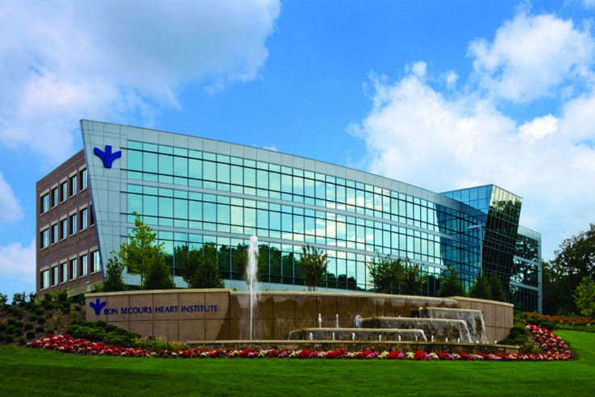

Dear Valued Sponsor:
On behalf of the Virginia Point-of-Care Coordinators, we are pleased to extend to you an invitation to participate in a Vendor Fair and Vendor Showcase Session to be held on Friday, July 15th, 2022 at the Bon Secours Heart Institute at Reynolds Crossing located at 7001 Forest Ave, Richmond, VA 23230.
Each vendor will receive full meeting registration for two representatives, admission to the educational session, lunch, and an opportunity to network with Virginia Point of Care Coordinators and showcase your latest products. The cost per table per vendor will be $200.00. Since space restrictions limit us to 6-8 vendor tables, applications to exhibit will be accepted as they are received until all spaces have been assigned. To reserve your exhibit table, please submit a completed application form (enclosed) along with the exhibit fee prior to Friday, July 1st, 2022. Contact Jennifer Boswell at jcboswel@sentara.com with any questions.
At the completion of the Vendor Fair, the afternoon session will include a Vendor Showcase which will allow the first six responses to participate. You will be given 5 minutes to speak about the latest release of your products.
Thank you for your support of the Virginia Point-of-Care Coordinators Educational Forum and Vendor Fair. Without your support, our programs and activities would not be possible. We look forward to seeing you at the meeting!
Sincerely,
Jennifer Boswell
Virginia Point of Care Coordinators, President Elect

APPLICATION FOR EXHIBIT SPACE
Application for exhibit space at the July 15th Virginia POCC meeting indicates the applicant’s willingness to abide by all accompanying exhibit terms and conditions, general regulations as well as such additional rules and regulations as the conference management deems necessary for the success of the exhibit.

Company Name _________________________________________
Contact Person _________________________________________
Mailing Address ________________________________________
______________________________________________________
Phone ________________________________________________
e-mail ________________________________________________
Product Description ______________________________________

Authorized Signature _____________________________________
Please print name _________________________________________

This application along with the exhibit fee of $200.00 should be signed and received before July 1st, 2022 to:
Jennifer Boswell 545 Sonshine Drive Ringgold, VA 24586

Confirmation of your reservation will be sent by e-mail. Please indicate special exhibit needs including specific electrical requirements, outlets, etc.:
__________________________________________________________________________________________________________________________________________________________________________

Provide names of vendor representatives per table. Please print.
1. _____________________________________________________
2. ____________________________________________________

