REGISTRATION

Reply by Email: jjkrem13@yahoo.com

If additional people in your organization are interested in attending, feel free to copy this form.

There is a $20.00 meeting registration fee for all non-KEYPOCC members.

Name:

Title:
Institution:
Address:
City:
State & Zip:
Phone:
Email:

Hilton Garden Inn
530 Pennsylvania Ave.
Ft. Washington, PA 19034

“KEYPOCC is approved as a provider of continuing education programs in the clinical laboratory sciences by the ASCLS P.A.C.E. ® Program.”
3.5 CEU credits for today’s session.

**Space is limited! Please respond by Thursday, September 10th**

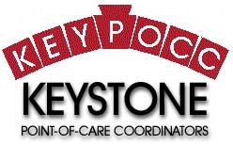

Neonatal Jaundice and Bilirubin Measurement -
Are we doing it right?

Point of Care Lactate Testing- An Essential Tool for the Management of Critically Ill Patients

Extended Claims of StatStrip Glucose that covers all patients. FDA new performance requirements and off label use of BGMS

September 15, 2015

Hosted by:
KEYPOCC

Special Thanks to:
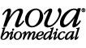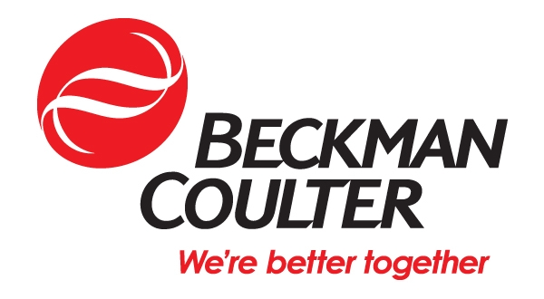
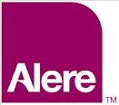

AGENDA

- 8:30 Continental Breakfast & Sign-in
- 9:00 Welcome & Announcements
- 9:15 Neonatal Jaundice and Bilirubin
Measurement -Are we doing it right?
-Martha Lyon, Ph.D.
- 10:45 Break
- 11:00 Vendor Presentation: Knowing Now Matters, the Importance of Rapid TAT, Test Targeting and Treatment in Various Disease States, Colleen Quinn, Alere
- 11:15 Point of Care Lactate Testing- An Essential Tool for the Management of Critically Ill Patients-Evangelos Ntrvalas, MD, Ph.D.
- 12:15 Lunch and Visit Vendors
- 13:15 Vendor Presentation : “Which Test for Which Setting”, Mark Johnson from Beckman
- 13:30 Extended Claims of StatStrip Glucose that covers all patients. FDA new performance requirements and off label use of BGMS-Ron Newby
- 14:30 Break
- 14:45 Business Meeting and Adjourn

SPEAKERS

Martha Lyon, Ph.D.
Dr. Martha Lyon is a Clinical Biochemist specializing in POC and Pediatrics since 2000. She is a Diplomat
American Board of Clinical Chemistry and Fellow of the National Academy of Clinical Biochemistry.

Evangelos (Evan) Ntrivalas, MD Ph.D.,
Director of Medical & Scientific Affairs, North America, at Nova Biomedical, Waltham, MA.
Dr. Evan Ntrivalas is Director of Medical and Scientific Affairs Nova Biomedical. Board certified lab director. He holds a MD and a Ph.D. in Micro and Immunology.
.
Ronald Newby
Director of Marketing at Nova Biomedical in Waltham, MA.
Ron received a Bachelor of Science from Michigan State University in microbiology and public health. After graduating, he worked as a clinical microbiologist at Henry Ford Hospital in Detroit, MI and at St. Charles Hospital in Toledo, OH. He moved into sales with Analytical Products Inc. (API), and then as a sales representative with Nova Biomedical, covering Michigan, Ohio, Indiana, Kentucky, and Ontario. In December 1992, Ron moved to Waltham, MA, where he continues to serves as Director of Marketing, with a focus on Nova’s point-of-care meter systems.

